Consider the pushdown automaton with the following transition rules:
- δ(q, 0, Z₀) = { (q, XZ₀) }
- δ(q, 0, X) = { (q, XX) }
- δ(q, 1, X) = { (q, X) }
- δ(q, ε, X) = { (p, ε) }
- δ(p, ε, X) = { (p, ε) }
- δ(p, 1, X) = { (p, XX) }
- δ(p, 1, Z₀) = { (p, ε) }
The start state is q. For which of the following inputs can the PDA first enter state p with the input empty and the stack containing XXZ₀ [i.e. the ID (p, ε, XXZ₀) ]
PUSHDOWN AUTOMATON: DEFINE AND SIMULATE:
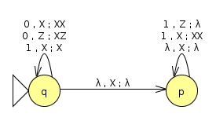Pushdown automaton

RESULTS:
String | Number of steps
0011100 | 9
0111011 | 8
1100101 | NO END
010101 | 7
0101010 | 9
0011011 | 8
011001101 | 11

